­­

Print Out Source Code Program

package soaltambahan;

import java.time.LocalDate;

import java.time.LocalTime;

import java.util.Scanner;

public class SoalTambahan {

public static void main(String[] args) {

Scanner in=new Scanner(System.in);

LocalTime time= LocalTime.now();

LocalDate date = LocalDate.now();

controller control=new controller() ;

String plat;

String tanggal;

int waktuMasuk;

int waktuKeluar;

int by,c=0;

char stnk,karcis,ljt='y';

int menu;

do{

// System.out.println(tanggal);

System.out.println("=================================================");

System.out.println("============= Tempat Parkir =============");

System.out.println("================= Parking System ================");

System.out.println("|| 1. Motor Masuk ||");

System.out.println("|| 2. Motor Keluar ||");

System.out.println("|| 3. EXIT ||");

System.out.println("=================================================");

System.out.print("Pilihan : ");

menu=in.nextInt();

switch(menu){

case 1 :

Print Out Source Code Program

case 1 :

System.out.println("=================================================");

System.out.println("============= Tempat Parkir =============");

System.out.println("================= Parking System ================");

System.out.println("Motor masuk : ");

System.out.print("PLAT NO : ");

plat=in.next();

tanggal=date.toString();

System.out.println("Tanggal : "+tanggal);

waktuMasuk= time.getHour();

int min = time.getMinute();

System.out.println("Waktu IN (24 hour): "+waktuMasuk+"."+min);

waktuKeluar=time.getHour();

by=0;

control.tambahParkir(plat, tanggal, waktuMasuk, waktuKeluar, by);

break;

case 2 :

System.out.println("=================================================");

System.out.println("============= Tempat Parkir =============");

System.out.println("================= Parking System ================");

for(kendaraan mtr:control.getALL()){

System.out.println("index = "+c+" plat = "+mtr.getPlat());

c++;

}

System.out.println("-------------------------------");

System.out.print("Motor keluar (index ke): ");

c=in.nextInt();

waktuKeluar=time.getHour();

min=time.getMinute();

System.out.println("Waktu pukul (24 hour) : "+waktuKeluar+"."+min);

control.tambahParkir(c, waktuKeluar);

Print Out Source Code Program

System.out.println("=================================================");

System.out.println("keterangan : ");

System.out.print("Karcis (Y/T) = ");

karcis=in.next().charAt(0);

System.out.print("STNK (Y/T) = ");

stnk=in.next().charAt(0);

control.ongkos(karcis, c, stnk, waktuKeluar);

break;

case 3 :

System.out.print("bye.......");

int sure = 0;

System.exit(sure);

break;

}

}

while(ljt == 'y');

}

}

Keterangan Source Code :

------------------------------------------------------------------------------------------------------------------------------------------------------------------------------------------------------------------------------------------------------------------------------------------------------------------------------------------------------------------------------------------------------------------------------------------------------------------------------------------------------------------------------------------------------------------------------------------------------------------------------------------------------------------------------------------------------------------------------------------------------------------------------------------------------------------------------------------------------------------------------------------------------------------------------------------------------------------------------------------------------------------------------

Print Out Source Code Program

package soaltambahan;

public class kendaraan {

String plat;

String tanggal;

int waktuMasuk;

int waktuKeluar;

int by;

kendaraan(String plat,String tanggal,int waktuMasuk,int waktuKeluar,int by){

this.plat=plat;

this.tanggal=tanggal;

this.waktuKeluar=waktuKeluar;

this.waktuMasuk=waktuMasuk;

this.by=by;

}

// public void setWaktuKeluar(int waktuKeluar) {

// this.waktuKeluar = waktuKeluar;

// }

public int getBy() {

return by;

}

public String getPlat() {

return plat;

}

public String getTanggal() {

return tanggal;

}

public int getWaktuMasuk() {

return waktuMasuk;

}

public int getWaktuKeluar() {

return waktuKeluar;

}

}

Keterangan Source Code :

---------------------------------------------------------------------------------------------------------------------------------------------------------------------------------------------------------------------------------------------------------------------------------------------------------------------------------------------------------------------------------------------------------------------------------------------------------------------------------------------------------------------------------------------------------------------------------------------------------------------------------------------------------------------------------------------------------------------

---------------------------------------------------------------------------------------------------------------------------------------------------------------------------------------------------------------------------------------------------------------------------------------------------------------------------------------------------------------------------------------------------------------------------------------------------------------------------------------------------------------------------------------------------------------------------------------------------------------------------------------------------------------------------------------------------------------------

---------------------------------------------------------------------------------------------------------------------------------------------------------------------------------------------------------------------------------------------------------------------------------------------------------------------------------------------------------------------------------------------------------------------------------------------------------------------------------------------------------------------------------------------------------------------------------------------------------------------------------------------------------------------------------------------------------------------

---------------------------------------------------------------------------------------------------------------------------------------------------------------------------------------------------------------------------------------------------------------------------------------------------------------------------------------------------------------------------------------------------------------------------------------------------------------------------------------------------------------

Print Out Source Code Program

package soaltambahan;

import java.util.ArrayList;

public class controller implements biaya{

ArrayList<kendaraan> list;

int ongkosh=0;

final int harga=5000;

controller(){

list = new ArrayList<>();

}

// final void setHarga(){

// int harga = 5000;

// }

public void tambahParkir(int c,int waktuKeluar){

String plat=list.get(c).getPlat();

String tanggal=list.get(c).getTanggal();

int waktuMasuk=list.get(c).getWaktuMasuk();

int by=0;

list.set(c, new kendaraan(plat,tanggal,waktuMasuk,waktuKeluar,by));

}

public void tambahParkir(String plat,String tanggal,int waktuMasuk,int waktuKeluar,int by){

kendaraan motor=new kendaraan(plat,tanggal,waktuMasuk,waktuKeluar,by);

list.add(motor);

}

public void ongkos(char karcis,int c,char stnk,int waktuKeluar){

ongkosh=(list.get(c).getWaktuKeluar()-list.get(c).getWaktuMasuk())\*harga;

checkKeluar(karcis,stnk);

int by=ongkosh;

System.out.println("Bayar = "+ongkosh+"\nHarap bayar dengan uang pas..!!!");

String plat=list.get(c).getPlat();

Print Out Source Code Program

String tanggal=list.get(c).getTanggal();

int waktuMasuk=list.get(c).getWaktuMasuk();

list.set(c,new kendaraan(plat,tanggal,waktuMasuk,waktuKeluar,by));

}

public ArrayList<kendaraan>getALL(){

return list;

}

public void checkKeluar(char karcis, char stnk) {

if((karcis=='Y' || karcis == 'y') && (stnk=='Y' || stnk=='y')){

ongkosh=(harga);

}

else if((karcis=='T' || karcis == 't') && (stnk=='T' || stnk=='t')){

ongkosh=(harga+((harga\*25)/100)) + 100000;

}

else if ((karcis=='Y' || karcis == 'y') && (stnk=='T' || stnk=='t')){

ongkosh=(harga + 100000);

}

else if ((karcis=='T' || karcis == 't') && (stnk=='Y' || stnk=='y')){

ongkosh= (harga+((harga\*25)/100));

}

else{

ongkosh=harga;

}

}

}

Keterangan Source Code :

---------------------------------------------------------------------------------------------------------------------------------------------------------------------------------------------------------------------------------------------------------------------------------------------------------------------------------------------------------------------------------------------------------------------------------------------------------------------------------------------------------------------------------------------------------------------------------------------------------------------------------------------------------------------------------------------------------------------

---------------------------------------------------------------------------------------------------------------------------------------------------------------------------------------------------------------------------------------------------------------------------------------------------------------------------------------------------------------------------------------------------------------------------------------------------------------------------------------------------------------------------------------------------------------------------------------------------------------------------------------------------------------------------------------------------------------------

---------------------------------------------------------------------------------------------------------------------------------------------------------------------------------------------------------------------------------------------------------------------------------------------------------------------------------------------------------------------------------------------------------------------------------------------------------------------------------------------------------------------------------------------------------------------------------------------------------------------------------------------------------------------------------------------------------------------

---------------------------------------------------------------------------------------------------------------------------------------------------------------------------------------------------------------------------------------------------------------------------------------------------------------------------------------------------------------------------------------------------------------------------------------------------------------------------------------------------------------

Print Out Source Code Program

package soaltambahan;

public interface biaya {

void checkKeluar(char karcis,char stnk);

}

Keterangan Source Code :

---------------------------------------------------------------------------------------------------------------------------------------------------------------------------------------------------------------------------------------------------------------------------------------------------------------------------------------------------------------------------------------------------------------------------------------------------------------------------------------------------------------------------------------------------------------------------------------------------------------------------------------------------------------------------------------------------------------------

---------------------------------------------------------------------------------------------------------------------------------------------------------------------------------------------------------------------------------------------------------------------------------------------------------------------------------------------------------------------------------------------------------------------------------------------------------------------------------------------------------------------------------------------------------------------------------------------------------------------------------------------------------------------------------------------------------------------

---------------------------------------------------------------------------------------------------------------------------------------------------------------------------------------------------------------------------------------------------------------------------------------------------------

Print Out Source Code Program

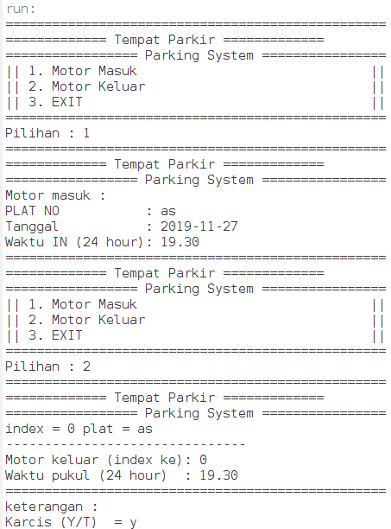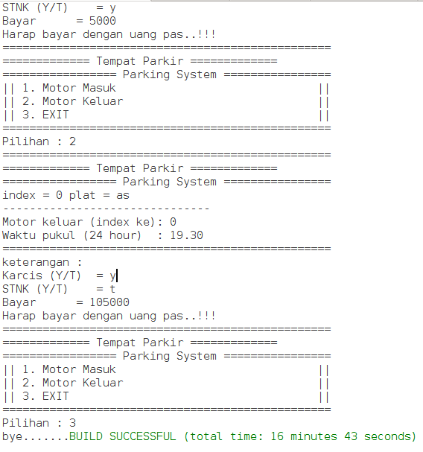

Keterangan Source Code :

---------------------------------------------------------------------------------------------------------------------------------------------------------------------------------------------------------------------------------------------------------------------------------------------------------

---------------------------------------------------------------------------------------------------------------------------------------------------------------------------------------------------------------------------------------------------------------------------------------------------------

--------------------------------------------------------------------------------------------------------------------------------------------------------------------------------------------------------------------------------------------------------------------------------------------------------

Print Out Source Code Program

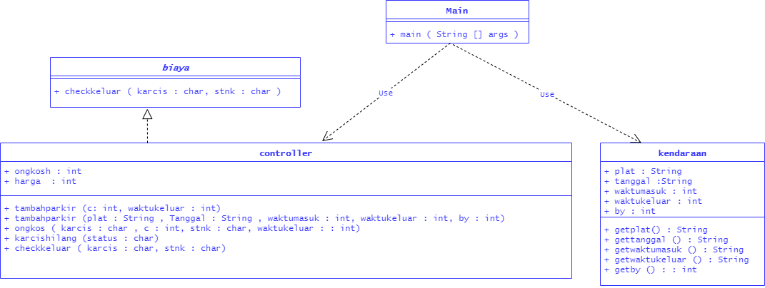

Keterangan Source Code :

---------------------------------------------------------------------------------------------------------------------------------------------------------------------------------------------------------------------------------------------------------------------------------------------------------

---------------------------------------------------------------------------------------------------------------------------------------------------------------------------------------------------------------------------------------------------------------------------------------------------------

--------------------------------------------------------------------------------------------------------------------------------------------------------------------------------------------------------------------------------------------------------------------------------------------------------

--------------------------------------------------------------------------------------------------------------------------------------------------------------------------------------------------------------------------------------------------------------------------------------------------------